You can edit your own version in one of two ways:
- Edit this version to fit your needs
- Go to File > Save As

How to Use This Template
This template will guide you through building a Test Case Template. It includes:
- Purpose
- Scope
- Test Case Template
- Test Case Workflow

Once you’re ready to begin, delete pages 1–2 and start filling out your info below.

There will be instructions and sample text, as well as prompts in <brackets> for you to complete. Remember, you should add/edit/delete any copy or sections as you see fit.


Your Partner in Test Automation
Companies have a lot to gain from Test Automation. But before you blindly jump in, planning is key and creating a Test Case Template is a great place to start.
Enhops is here to help wherever you are in your Test Automation journey.
ENHOPS.COM

Keep scrolling to template
↓↓↓

Test Case Template
Effective Date | <Effective Date>
Name of Template | Test Case
Template Owner | <Template Owner>
Date Created | <Date Created>
Date Modified | <Date Modified>

Introduction, Purpose, and Principles: This section provides an overview of the Test Case Template, who it applies to, and the reasons for its implementation. Explain the ‘why’ and objectives of the Test Case Template to set the context for employees. Write in clear and concise language, using a tone appropriate for your organization's culture.

Introduction
The “Organization” | <Company Name>
This Test Case Template (the “Template”) outlines the guidelines and principles governing the use of Test Case Template within the company (the “Organization”). The Template aims to ensure that Test Cases are created consistently and efficiently.
Purpose
The purpose of  this Template is to: | <Example #1: Establish clear guidelines for developing Test Cases within the Organization.>

Scope
On behalf of the Organization, this  Template applies to: | <Groups Who Work in QA Vertical>
Template
- Issues ID: | <Unique Number>  Describes the test case number and it is automatically generated by the tool

- Project: | <Text>  Describes the Project for which the test case will be created

- Issue Type: | <Text>  Describes the issue type as Test

- Summary: | <Text>  Describes the summary or title of test case

- Component (s): | <Text>  Describes the functionality/feature for which test case will be created

- Description: | <Text>  Indicates the detailed description of the test case

- Priority: | <Alphanumeric Characters>  Describes the business priority of the test case. Values includes,  - P0 Critical) - The test cases MUST be executed; else the consequences may not be good after the product is released. These are critical test cases where the chances of getting a functionality disrupted due to a new feature is most likely possible.  - P1 (High) - The test cases SHOULD be executed. These are not very critical cases, but should be executed to ensure the changes are working as expected.  - P2 (Medium) - The test cases are NOT important to be tested prior to the current release. These can be tested later, shortly after the release of the current software version.  - P3 (Low) - The test cases are never important, as their impact is nearly negligible.

- Issues Links: | <Text>  Describes the tests which has parent/child relationship

- Test Steps: | <Text>  Describes the steps to execute the test case

- Test Data: | <Alphanumeric Characters>  Describes the data required to execute the test case

- Expected Result: | <Text>  Describes the expected result from test case execution

- Environment: | <Text>  Indicates the environment on which test case is to be executed

- Acceptance Criteria: | <Text>  Describes the acceptance criteria for which the test case is created/to be executed

Test case workflow
Test Case Workflow is defined at ‘Status’ field in Test Management Tool. This field will be updated as per the workflow defined while creating new test case.
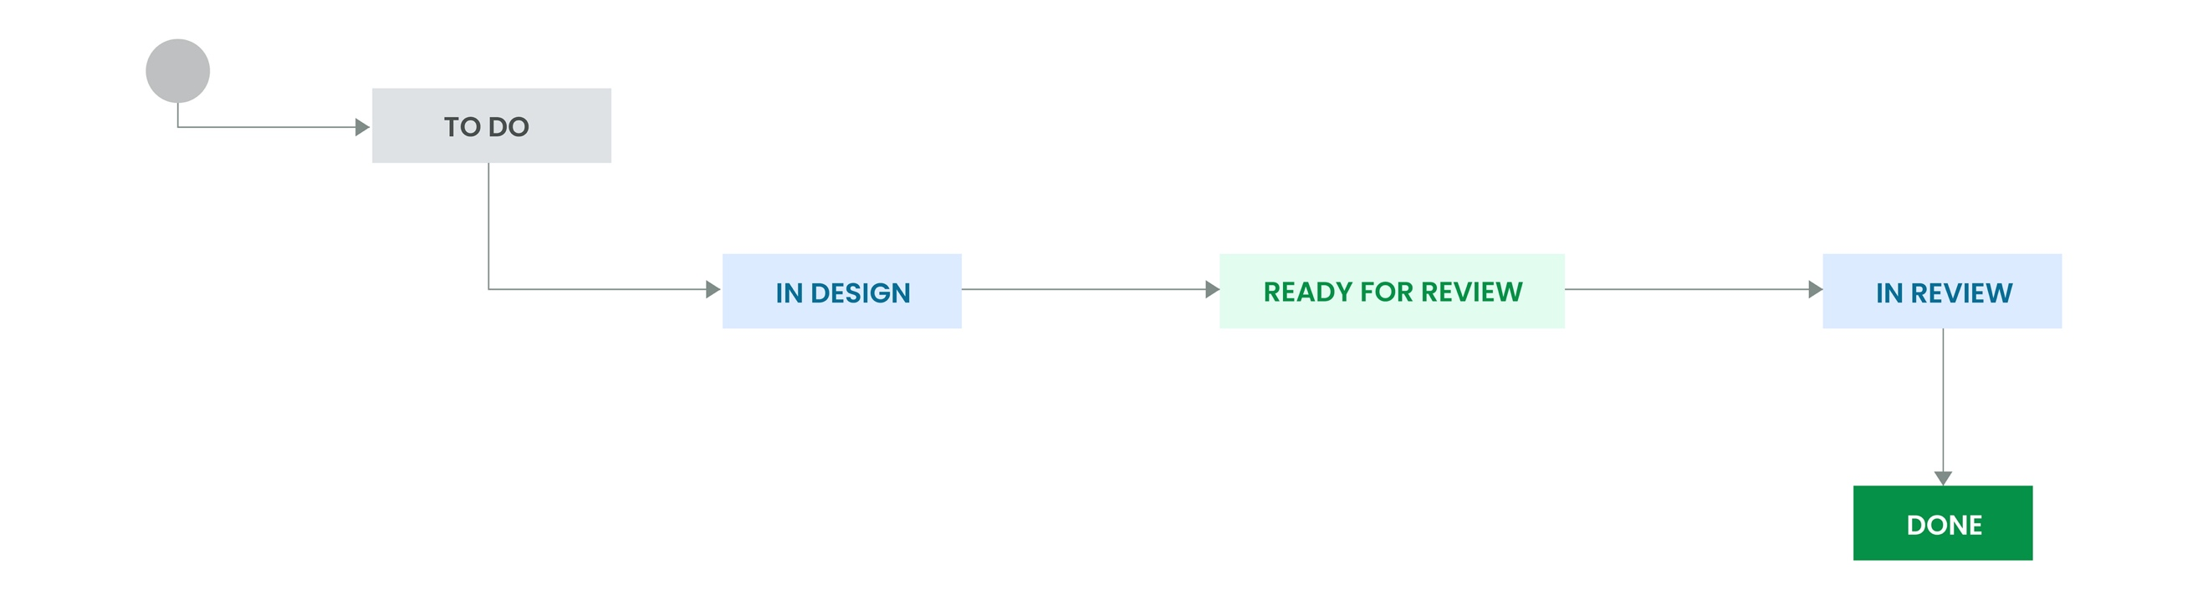
The values of status field include,
- To Do: Indicates that the test case is to be designed
- In Design: Indicates that the test case is in design state
- Ready for Review: Indicates that the test case is ready for review
- In Review: Indicates that the test case is in review
- Done: Indicates that the test case design is completed

